From: https://medium.com/@caityjohnstone/breaking-everyone-who-opposes-war-is-a-russian-antisemite-39fd8acf316a

BREAKING: Everyone Who Opposes War Is A Russian Antisemite

Caitlin Johnstone
Mar 14 [2019]
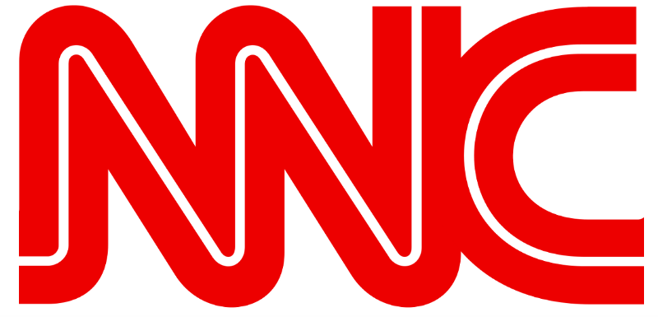
In order to appease the internet censors, today’s Caitlin Johnstone article has been replaced with a breaking report from the National News Conglomerate. NNC: Obey.
Washington, D.C. (NNC) — Following the publication of the results of a groundbreaking new study this week, experts are now reporting that every single person who questions western military interventionism is both an antisemitic bigot and a Russian national.
Research analyst Les Overton is a senior fellow at the American Society for the Prevention of Cruelty to Democracy (ASPCD), a Washington, D.C.-based think tank whose motives we can only assume are perfectly truthful and unbiased. He told NNC that the ASPCD’s research clearly shows that the rate of correlation between an individual opposing western foreign policy, harboring a virulent hatred of Jewish people, and being a citizen of the Russian Federation is “at least a hundred percent, if not more.”
“This is not to suggest that all Russians are antisemites or that all antisemites oppose American wars,” Overton reports. “Our research shows only that people who do oppose western military interventionism are both of these things.”
These findings track with revelations exposed by respected foreign policy analyst Max Boot in an article published yesterday in the Washington Post titled “It’s time to retire the ‘neocon’ label”. Boot explains that those who criticize the relentless warmongering of neoconservatism are actually facilitating antisemitism, writing that antiwar voices have been known to use that label “to suggest that Jews are running U.S. foreign policy.”
These findings also help explain the fact that
- British Labour leader Jeremy Corbyn and
- US Congresswomen Tulsi Gabbard and
- Ilhan Omar
have all been found to be arousing suspicion with their irrational affection for Vladimir Putin and irrational disdain for people of Jewish ancestry.
“Take Tulsi Gabbard, a longtime critic of US interventionism,” Overton said while explaining how ASPCD reached its conclusions. “Her affection for Syria’s Bashar al-Assad is well-documented, and Assad, being an ally of Putin, is effectively Russian. This makes Tulsi Gabbard a Russian by proxy, which probably explains why Putin loves her so much.”
“Interestingly, we have also found this same correlation between individuals who believe that poor people should be treated with kindness, and those who believe Palestinians are human beings,” added Overton. “We found a direct, causal and completely ubiquitous correlation between
- sympathy for impoverished and Palestinian people,
- a hatred of Jews, and an
- unwavering loyalty to Mother Russia.”
Overton advises westerners who find themselves questioning the wisdom and beneficence of the current liberal democratic world order that they can avoid the overpowering urge to betray their country to the Kremlin and begin loading Jews onto cargo trains by “watching lots of television and just kind of zoning out about everything.”
__________________
__________________
__________________
Thanks for reading! My shamefully seditious articles are entirely reader-supported, so if you enjoyed this piece please consider sharing it around, liking me on Facebook, following my antics on Twitter, throwing some money into my hat on Patreon or Paypal, purchasing some of my sweet merchandise, buying my new book Rogue Nation: Psychonautical Adventures With Caitlin Johnstone, or my previous book Woke: A Field Guide for Utopia Preppers. The best way to get around the internet censors and make sure you see the stuff I publish is to subscribe to the mailing list for my website, which will get you an email notification for everything I publish.
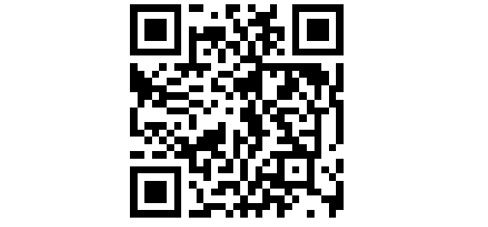
Bitcoin donations:1Ac7PCQXoQoLA9Sh8fhAgiU3PHA2EX5Zm2
- Satire
- War
- Propaganda
- Media Criticism
- Caitlin Johnstone
934 claps
8
• Following


Caitlin Johnstone
Rogue journalist. Bogan socialist. Anarcho-psychonaut. Guerrilla poet. Utopia prepper.

[The above derives from the much older item, below.]

From: https://www.zerohedge.com/news/2018-11-28/leaked-transcript-proves-russiagaters-have-been-right-all-along-spoiler-not-really

Leaked Transcript Proves Russiagaters Have Been Right All Along (Spoiler: Not Really)

by Tyler Durden
Wed, 11/28/2018 - 19:25
Authored by Caitlin Johnstone via Medium.com,
A transcript of exchanges between US President Donald Trump and Russian President Vladimir Putin has been leaked to National News Conglomerate by an anonymous source within the Kremlin. We here at NNC have confirmed the authenticity of this document using the same rigorous verification process we’ve been using to authenticate the evidence for all our other reporting on Russia’s involvement in the 2016 US elections over the last two years. These verification methods include hunches, gut intuitions, and an introspective assessment of the way our feelings feel. The following exchanges revealed in this transcript provide the clearest evidence yet that the President of the United States has been in collusion with the Russian government for years.
This introduction has been authored by the editorial board of the National News Conglomerate. Obey.
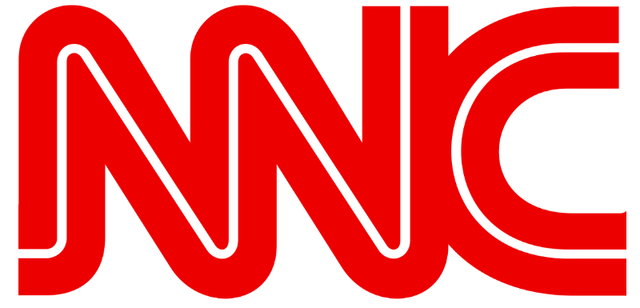
11/9/2016
Trump: I have done as you commanded, my dominant and all-powerful lord. I have conspired with your hackers to steal the election, and now I’m going to be president! I want to thank you for not releasing that video footage of those Russian prostitutes I hired to urinate on a bed the Obamas once slept in. If that had come out it would have offended and alienated a lot of people, which is something I never normally do.
Putin: Yes that is an old KGB tactic called kompromat, a word which only extremely intelligent people know about. Keep this line of communication open. As long as you do as I command, your pee pee tape will remain secret.
Trump: One thing I’m curious about though my lord, if you don’t mind my asking. If you already had an army of hackers targeting Democratic Party emails, why did you need my help? Couldn’t you just have hacked the emails and published them on your own? Why did you need me to interact with them at all?
Putin: Moral support, mainly. We don’t need to get into specifics.
Trump: Oh okay.
~
1/20/2017
Trump: I’m in! Whew! I was really worried that leaked dossier would be the end of me! What are my instructions, my lord?
Putin: Begin introducing racism and division to the United States. America has never experienced these things before, and it will shock and disorient them. With the US divided against itself, your nation will be far too weak to stand against my plans of total world domination.
Trump: That’s a really tall order! America has always been a harmonious place where everyone gets along up until today. I’ll try my best though. Anything else?
Putin: Yes, make them distrust your nation’s large media outlets and convince them that the US intelligence community is often dishonest.
Trump: That will be really hard because those institutions have always been trusted for their unparalleled integrity. But your wish is my command, oh lord.
~
4/7/2017
Putin: Bomb a Syrian airbase.
Trump: What? Really? Aren’t they, like, your allies?
Putin: Exactly. This will throw inquisitive minds off the scent. We can’t have them finding out about that pee tape.
Trump: Are you sure? Some people are saying that chemical attack looks like it could have been perpetrated by the many terrorist factions in Syria and not the government.
Putin: Who cares? Have you seen how relentless they’ve been in exposing us?? Have you never watched Rachel Maddow? That woman is a psychic bloodhound, masterfully sniffing out the truth at every turn! We can’t afford to take chances. Do as I say.
Trump: Yes sir.
Putin: And see if you can arrest that WikiLeaks guy.
~
5/14/17
Trump: Hey do you want me to do anything about Montenegro’s addition to NATO?
Putin: No. NATO expansion is good.
Trump: Uhhh okay.
~
6/28/17
Trump: Who do you want tapped for Ukraine envoy?
Putin: Kurt Volker.
Trump: Volker? He hates you! He’s like the biggest Russia hawk ever.
Putin: We still need to throw the Russiagaters off the scent. We’re playing 3-D chess here. This is high-level disinformation, or dezinformatsiya as very smart people call it. I want as many Russia hawks in your administration as possible.
Trump: 3-D chess? Alright. I guess you know what you’re doing.
~
8/30/17
Putin: Shut down the Russian consulate in San Francisco and throw out a bunch of diplomats. That will confuse the hell out of them.
~
11/21/17
Putin: Now approve the sale of arms to Ukraine. Not even Obama would do that. This will throw them off the trail for sure.
~
1/1/18
Putin: Happy new year. Force RT and Sputnik to register as foreign agents.
~
1/29/18
Putin: Make sure your Nuclear Posture Review greatly escalates its aggressive posture toward Russia.
~
2/14/18
Putin: Happy Valentine’s Day. Don’t worry about those Russians your guys killed in Syria.
~
2/19/18
Putin: Send a fleet of war ships to the Black Sea.
~
3/25/18
Putin: Better expel a few dozen diplomats over the Skripal thing.
~
4/5/18
Putin: Sanction a bunch of Russian oligarchs.
~
4/10/18
Putin: Bomb Syria.
Trump: What?? Again?
Putin: Yes.
Trump: What the hell, man? Why’d you even recruit me if you’re just going to have me do everything all the Russia hawks want?
Putin: Well, you know how I told you we were playing 3-D chess against the Russiagate investigation?
Trump: Yeah?
Putin: Well that wasn’t enough. Now we’re playing 4-D chess.
Trump: Fine, whatever, I don’t care. Just don’t release my pee tape.
~
7/17/18
Trump: Oh man. They’re really making a major fuss about that summit. What should I do?
Putin: Play it cool. Don’t let them know about our secret diabolical plot.
Trump: Right. Remind me what that was again?
Putin: Make Jim Acosta feel really, really sad.
~
9/2/18
Putin: Have you arrested Julian Assange yet?
Trump: Working on it.
~
10/20/18
Putin: I like John Bolton’s idea. Pull out of the Intermediate-Range Nuclear Forces Treaty.
~
11/25/18
Putin: Make sure your administration loudly and aggressively backs Ukraine in our Kerch Strait spat.
Trump: OMFG this is getting too weird. Are you just trolling me? What the hell is this?
Trump: Hello?
Trump: Are you there?
Trump: Answer me!
Putin: 5-D chess.
* * *
Thanks for reading! The best way to get around the internet censors and make sure you see the stuff I publish is to subscribe to the mailing list for my website, which will get you an email notification for everything I publish. My articles are entirely reader-supported, so if you enjoyed this piece please consider sharing it around, liking me on Facebook, following my antics on Twitter, throwing some money into my hat on Patreon or Paypal, buying my new book Rogue Nation: Psychonautical Adventures With Caitlin Johnstone, or my previous book Woke: A Field Guide for Utopia Preppers.
Bitcoin donations:1Ac7PCQXoQoLA9Sh8fhAgiU3PHA2EX5Zm2

